**WIRESHARK SNIFFER**

**Ex No:09**

**Date:09-05-2023**

**Aim:**

* TO use WireShark sniffer tool to capture and analyse traffic.

**Procedure:**

1. Install and open Kali Linux.
2. Open the wireshark sniffer tool.
3. Connect to a network.
4. Open any website.
5. Now in the tool click on the connection type (Example eth0).
6. Now click on capture and start capturing the data.
7. We can filter the packets too in filter search bar.

**Output:**

Wireshark tool

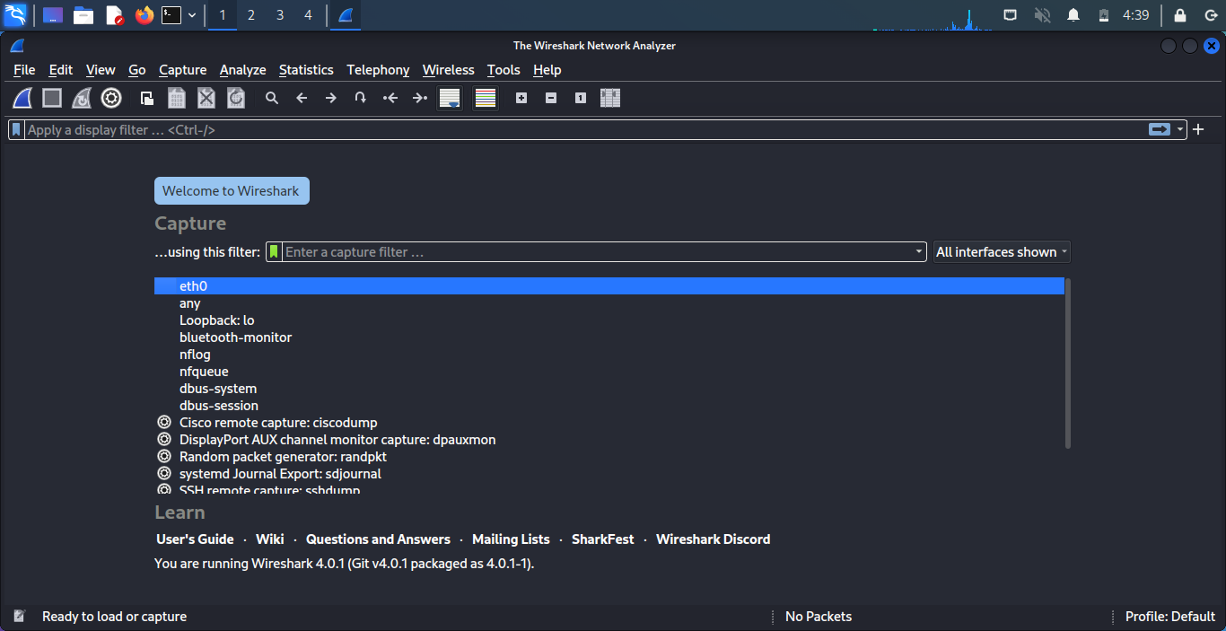

Open any website or domain

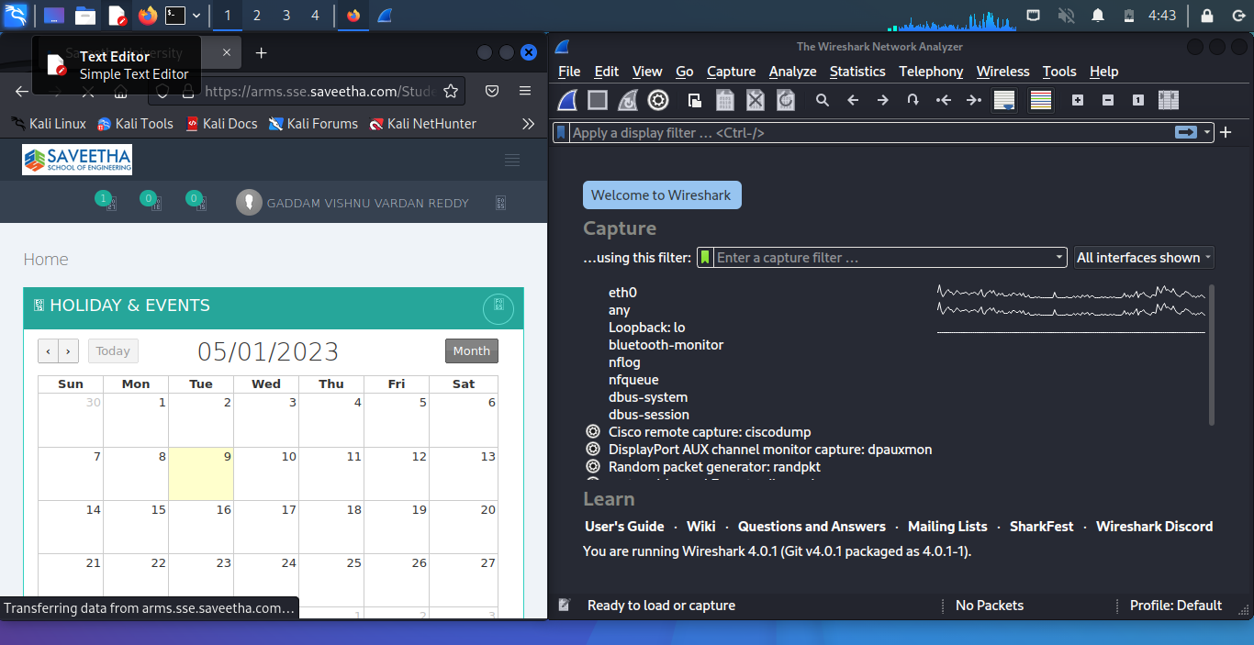

Click on capture

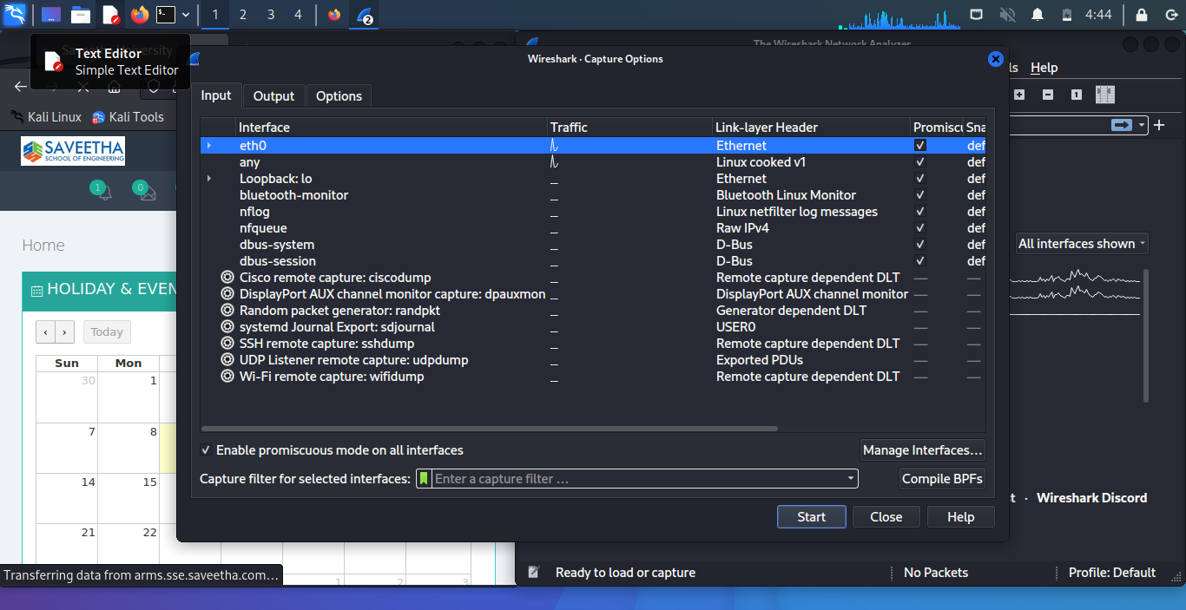

You can see all the packets that are being transferred

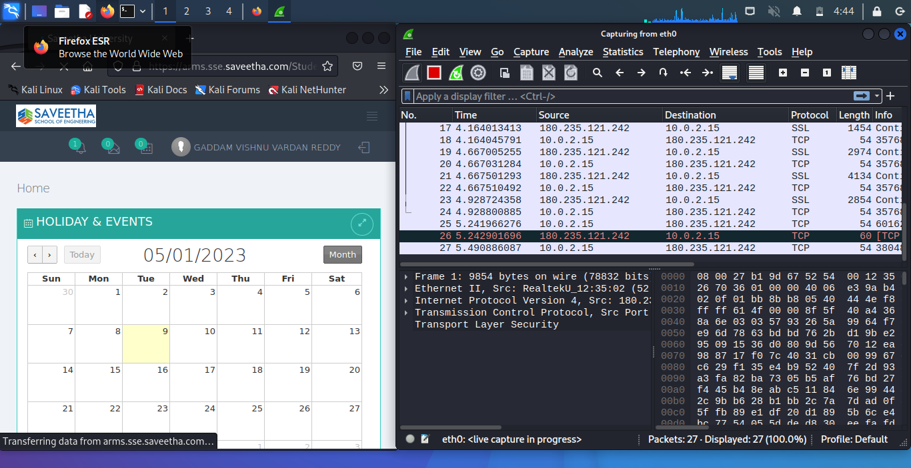

You can filter those packets too (Example TCP)

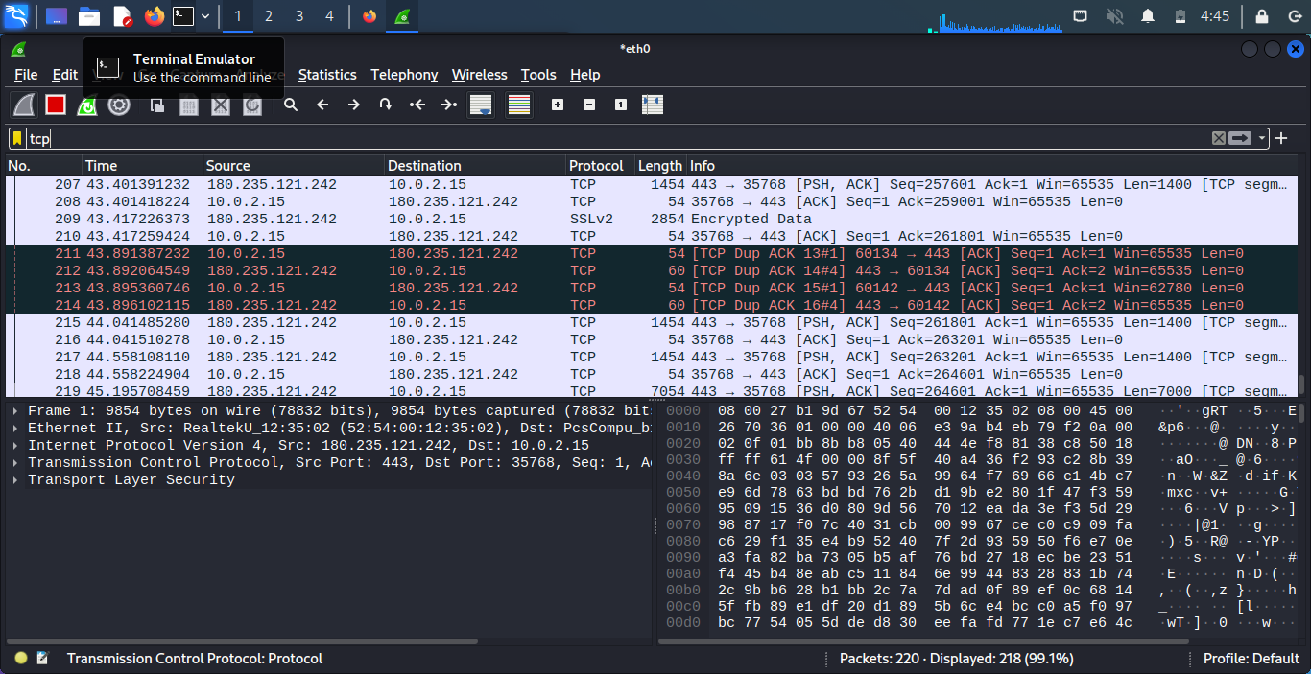

**Result**

Hence using WireShark sniffer tool traffic has been analysed and captured.